Ideation Phase
Define the Problem Statements

Date | 2 November 2025
Team ID | NM2025TMID02717
Project Name | Optimizing User, Group, and Role  Management with Access Control and Workflows
Maximum Marks | 2 Marks

Customer Problem Statement Template:

Problem Statement:
Alice and Bob, a two-person project team using ServiceNow, face ongoing challenges due to undefined roles, weak access controls, and the absence of structured task workflows. This
causes role confusion, delayed task execution, and limited project transparency. Without an automated system that aligns permissions with roles and tracks assignments efficiently, the team struggles to stay on top of deliverables. Their ideal solution includes intelligent role
management, dynamic workflows, and real-time status visibility, helping them enhance collaboration, accountability, and project outcomes.

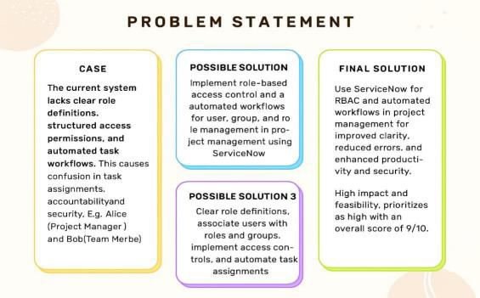

Example

Problem  Statement (PS) | Iam  (Customer) | I’mtrying to | But | Because | Which makes me feel
PS-1 | Project Manager (Alice) | Manage tasks and track  progress efficiently. | Lack  clarity on task  ownershi p and  status. | No defined roles, access controls, or structured workflows. | Confused, inefficient, accountable (difficult to track), frustrated
PS-2 | Team  Member (Bob) | Understand  and report  assigned task sclearly. | Unclear  responsib ilities and  update process. | No clear task guidelines or progress  tracking met hod. | Chaotic, slow, unclear, frustrated Anxious,  tense, lost

